Access to the Royal Observatory for Evening Events

The Royal Observatory is situated in the centre of a park which has variable closing times. These influence how you will access the site to attend your event. Please read the following information carefully to understand how to get to the Observatory when the park is closed.

Please aim to arrive at least 15 minutes before the event starts. If you arrive before park closing, please make your way to the Peter Harrison Planetarium Building, which is marked 2 on the map below and staff will direct you further. If you arrive after park closing and are on foot, please make your way to St Mary’s Gate, marked a on the map below, and a shuttle minibus service will be in operation to take you through the park and to the Observatory.

Detailed below are the park closing times and how this affects access:

Month | Park closure | Access on arrival | Access on departure
September | 20:00 | Arrive on foot | depart via minibus only
October | 19:00 | Arrive on foot until 18:50 then by minibus only | depart via minibus only
November | 18:00 | Arrive via minibus only | depart via minibus only
December | 18:00 | Arrive via minibus only | depart via minibus only
January | 18:00 | Arrive via minibus only | depart via minibus only
February | 18:00 | Arrive via minibus only | depart via minibus only
March | 19:00 | Arrive on foot until 18:50 then by minibus only | depart via minibus only
April | 20:00 | Arrive on foot | depart via minibus only
May | 21:00 | Arrive on foot | depart on foot/via minibus if after 21:00

a) How to Access the Royal Observatory on foot:

- If you arrive or leave when the park is open, you can walk through the park to and from the Royal Observatory.

- When the park is shut, there is no pedestrian access allowed in the park. To get to the Observatory, please take the free shuttle minibus service which will depart from St Mary’s Gate at the end of King William Walk – marked a on the map below. Please be aware that when the park is shut you will only be able to arrive or leave from the St Mary’s Gate via the minibus shuttle. Please be aware that the minibus is not wheelchair accessible. If you have any concerns or need to make alternate arrangements, please contact Bookings at bookings@rmg.co.uk or call our Bookings team on 0208 312 6608.

b) Access the Royal Observatory at night by bicycle:

- When the park is shut, there is no bicycle access to the Observatory. If you wish to travel by bicycle, you must lock your bike in the rack outside of St Mary’s Gate at the end of King William Walk and use the shuttle bus service.

c) How to Access the Royal Observatory at night by car:
- If you arrive at the Royal Observatory when the park is open (until 17:55), you can drive through the park to the Royal Observatory using Blackheath Gate (marked b)
- When the park is shut (after 18:00) you will only be able to arrive or leave from the St Mary’s Gate at the top of King William Walk - marked a on the map below – no other park gates will be open.
- Parking spaces are directly outside the entrance to the planetarium and are free after 18.00

Advice for all visitors

- Read the access instructions carefully to gain entry to the Observatory
- Please make sure that you wear warm clothes
- There are no lights in the park – so you may consider bringing a small torch to guide you
- Emergency contact number on the night 020 8312 6767
- If you have any access requirements which we should be aware of, please email our Bookings team on Bookings@rmg.co.uk

Getting to Greenwich

Average walking times from the St Mary’s Gates to the different destinations are shown in brackets. Our minibus will transport you between the Observatory and the St Mary’s Gates after the park has closed to the public.

Mainline stations Greenwich (15 minutes),
DLR station Cutty Sark (5 minutes)
Buses stopping in Greenwich 177, 180, 188, 199, 286, 386 (5 minutes)

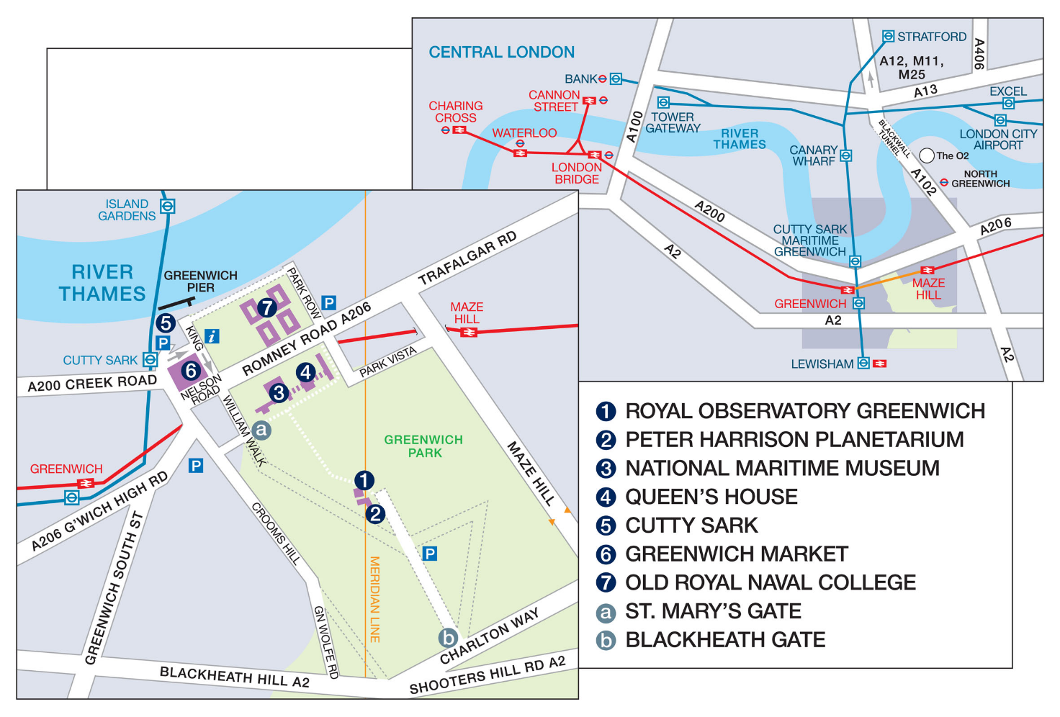
St Mary’s Gate – shuttle bus pick up and drop off point

Should you have any queries in advance please contact bookings on 020 8312 6608

